*BULLING AND HARRASSMENT ROLL OUT BOOKLET*

1. **WHAT IS BULLYING**

Bullying is when people repeatedly and intentionally use words or actions against someone or a group of people to cause distress and risk to their wellbeing. These actions are usually done by people who have more influence or power over someone else, or who want to make someone else feel less powerful or helpless.

Bullying is not the same as conflict between people (like having a fight) or disliking someone

The sort of repeated behaviour that can be considered bullying includes:

* Keeping someone out of a group (online or offline)
* Acting in an unpleasant way near or towards someone
* Giving nasty looks, making rude gestures, calling names, being rude and impolite, and constantly negative teasing.
* Spreading rumours or lies, or misrepresenting someone (i.e. using their Facebook account to post messages as if it were them)
* Mucking about that goes too far
* Harassing someone based on their race, sex, religion, gender or a disability
* Intentionally and repeatedly hurting someone physically
* Intentionally stalking someone
* Taking advantage of any power over someone else like a Prefect or a Student Representative.

Bullying can happen anywhere. It can be in schools, at home, at work, in online social spaces, via text messaging or via email. It can be physical, verbal, emotional, and it also includes messages, public statements and behaviour online intended to cause distress or harm (also known as [cyberbullying](https://humanrights.gov.au/bullying/factsheets/cyberbullying.html)).

But no matter what form bullying takes, the results can be the same: severe distress and pain for the person being bullied.

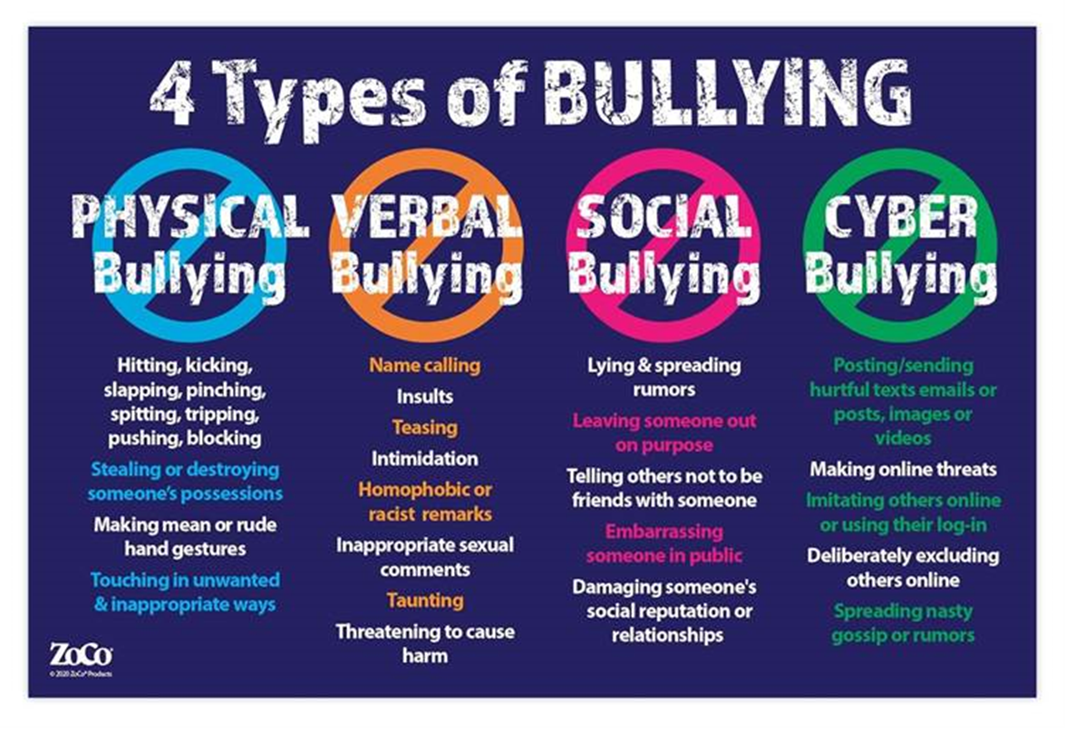

1. **HARASSMENT**

Harassment is unwelcome conduct that is based on race, colour, religion, sex (including sexual orientation, gender identity, or pregnancy), national origin, older age (beginning at age 40), disability, or genetic information (including family medical history).

Examples of harassment include offensive or derogatory jokes, racial or ethnic slurs, pressure for dates or sexual favours, unwelcome comments about a person's religion or religious garments, or offensive graffiti, cartoons or pictures.

**Types of Harassment and Examples**

Harassment covers a wide range of unwanted behaviour, including physical contact and verbal abuse that causes emotional distress to the harassed. There are seven common types of harassment charges:

**Domestic Violence**

Domestic violence occurs in a domestic or cohabitation setting, although the abuse itself doesn’t have to happen in a private setting. Abuse can happen between spouses, partners, family members, or even housemates

**Elder Abuse**

Elder abuse is mostly done by caregivers, such as family or employees at a nursing home. However, elder abuse can also be done by someone close to the elderly, such as fellow residents at a nursing home, neighbors, or family and friends.

**Workplace Harassment**

Occurs in the work environment. Often unwanted behaviors that undermine the victims. Usually actioned by managers & supervisors who feel that they are protected by their roles.

**Sexual harassment**

Sexual harassment can mean harassment caused by a person’s sex that makes the [harassed feel uncomfortable, unsafe, or humiliated](https://inspiredelearning.com/blog/effects-of-sexual-harassment-in-the-workplace/). It can also be considered as any unwanted sexual advances, such as inappropriate comments that are sexual in nature, requests for sexual favors, unwarranted physical touch, or even sexual assault.

**Civil harassment**

Often classified as acts of abuse by someone you don’t have a close relationship with. Abuse by a family member that doesn’t fall under the domestic violence case is also considered a civil harassment case

**Criminal Harassment**

Unwanted behaviour that makes people of certain groups feel unsafe.

For example, [a hate crime](https://www.justice.gov/hatecrimes/learn-about-hate-crimes) or harassment against a community (such as the LGBTQIA+ community) can be classified as criminal harassment. Remember the Xenophobic attacks.

**Cyber Bullying / Cyber stalking**

Cyber harassment, or [online harassment](https://inspiredelearning.com/blog/how-to-stop-electronic-harassment/), refers to acts that are designed to harm, stalk, or terrorize someone through any form of electronic communications, such as social media, text messages, or phone calls.

It’s easier to harass people virtually since it will be hard to track the parties involved. Cyber harassment can include harmful comments, derogatory websites, and untruthful posts, as well as hateful or offensive emails intentionally designed to terrorize a person.

* Cyber harassment, or [online harassment](https://inspiredelearning.com/blog/how-to-stop-electronic-harassment/), refers to acts that are designed to harm, stalk, or terrorize someone through any form of electronic communications, such as social media, text messages, or phone calls.
* It’s easier to harass people virtually since it will be hard to track the parties involved. Cyber harassment can include harmful comments, derogatory websites, and untruthful posts, as well as hateful or offensive emails intentionally designed to terrorize a person.

1. **Tafta Values**

To make dignity, growth and meaningful life a realistic prospect for all elders and the staff, we promote the following:

**Trust**

* Trust cements relationships by allowing people to live and work together, feel safe and belong to a group.
* The dynamics of trust are delicate in important relationships, and the loss of trust can be costly.
* Trust is an ongoing exchange between people and is not static.
* Trust can be earned. It can be lost. And it can be regained.

**Accountability**

* Accountability means that everyone is responsible for their actions, behaviors, performance and decisions.
* We work and achieve in teams
* We foster trust and integrity in internal relationships
* We consciously balance individual and group interests
* We hold each other accountable.

**Transparency**

* Transparency helps build stronger relationships.
* People will have more confidence in the leadership and the decisions that are being made within the Organisation because they know exactly what is happening and why it is happening.

**Care**

* It's a commitment to prioritize the well-being of individuals and promote a supportive and empathetic environment where everyone can flourish.
* By embracing and actively working towards a caring culture, organizations can reap the benefits and increase overall success.

**Respect**

* Respect is one of the most important traits in the workplace because it creates a positive work culture for you and the team to accomplish goals together.
* A respectful attitude should be the standard in any environment, regardless of personal feelings.
* We have high regard for each other and those we care for
* We give due consideration to the needs of everyone
* We show esteem to ourselves and our colleagues and each other
* We are consciously aware of and appreciate the diverse experiences of all.

**Integrity**

* We do the right thing, even when no one is watching
* We foster trust
* We are fair and ethical in our dealings
* We build our relationship for the long-term
* We are honest about our performance
* Our reputation lies in the actions and statements of every employee and resident.

**Purpose**

* Purpose defines our core reason for being and the positive impact we have on the world.
* It shapes our strategy and inspires those we serve.

**Service**

* We innovate and lead in a changing world
* We deliver quality services to our clients
* We build lasting relationships based on trust
* We understand and respect our client’s needs and perceptions
* We prize innovation and emotional engagement.
* Service can help our life and work be more meaningful.

**Compassion**

* Compassion fosters a strong sense of belonging and loyalty, leading to a more engaged and committed workplace.
* Our business is to care for older people
* We accept that mindfulness and thoughtfulness is expected of us
* We practice patience and tolerance to all
* We display a willingness to help others.

**Environmental Responsibility**

* We commit to taking steps to do no harm to our environment
* We explore new ways to be resource efficient
* We exploit every opportunity to reduce our carbon footprint

1. **House Rules: Why is it important to established house rules in the communal communities**

Maintaining order

* Rules help maintain order and ensure that everyone follows a consistent and predictable set of standards.
* This helps to prevent chaos and confusion and helps to promote a sense of security and stability within the community.
* Every home has rules. Family rules help everyone in your family get along better.
* Good family rules are positive, specific and easy to understand.
* Rules are focused on things like physical behavior, safety, manners, routines, respect and many more.

**Examples of Tafta’s House Rules**

* Meal – times
* Pets,
* Red tags/ discs
* Smoking zones
* Visitors
* Laundry
* Noise
* Stove/Microwaves

The list goes on depending on the home (units /rooms / life Rights / rented)

1. **Complaints Procedure and Policy**

**Flow chart for complaints:**

Complaint Lodged

Complaint Box

Resident or Staff Complaint

Acknowledge Complaint

In writing

Inform Complainant (time frame needed)

Investigate Complaint

Evidence needs to be recorded

Identify root causes

Resolving and Redressing Complaint

Redress

Meeting/ Letter/ Report

Monitoring

Statistics

Reviewing of complaints by Divisional Manager once in every 6 weeks

**5.1.3 COMPLAINTS PROCEDURE**

**5.1.3.1 Lodging a complaint**

* A notice outlining the process for complaints to be lodged must be visible in all buildings.
* ***Complaints must be lodged within 48 hours in the following manner:***

Complaints box- sealed box to be placed at reception area in all buildings

Face to face-direct contact

E mail-electronic to intake or staff

Telephonic-intake or direct to staff

* All complaints received from the complaints box / face to face / email /telephonic must be investigated and addressed with feedback
* The complaints box must be checked daily by BS.
* BS to record all complaints in the complaints register and allocate a reference no.
* Complaints to be escalated by BS to relevant staff for investigation.
* Suspected or alleged elder abuse to be referred to the Social Worker for urgent attention.

(Refer to the Older Persons Act 13 of 2006)

* If a complaint is related to a staff member, it should be escalated to the next line of authority.

**5.1.3.2 Acknowledgment of complaint**

* The relevant staff member will acknowledge receipt of complaint with the allocated reference number, in writing within 2 to 5 working days after referral of complaint.
* BS to submit complaints register to AM weekly for monitoring.
* ***Escalation process for complaints:***

Building Supervisor – Social Worker – Area Manager - Divisional Manager Operations- Chief

Executive officer.

* To record face to face/telephonic complaints
* BS to enter all complaints received into the complaints register

**5.1.3.3 Investigation of complaints**

* All complaints recorded in the complaint register to be investigated.
  + A timeframe for the investigation should be noted and communicated to the complainant.
  + Process notes of all interviews conducted during the investigation should be signed off by

interviewer and interviewee.

* + Upon finalisation of the investigation, written feedback must be sent to the complainant.
* If needed, mediation can be scheduled for resolution of the complaint.

**5.1.3.4. Monitoring of complaints**

* The AM/DM to sign off the complaints register on a monthly basis to ensure that the

complaints had been addressed.

* The Area based care team are to identify trends in the complaints lodged from elders and other care partners.

1. **Roles of the Social Worker**

* They will have structured times for decentralized intake, make scheduled appointments and have community work out days.
* Hospital drop offs and pick-ups- this is the responsibility of family. If there is no family, Social workers will liaise with Building supervisor to obtain assistance with volunteers, or an ambulance, or taxi, and Social worker will motivate for NPF for payment (as a last resort).
* The Building Supervisor to deal with incidences with residents and the building structure (e.g. loud radios, dirty flats etc.) Should there be a need for therapeutic intervention, or the repeated efforts of the Building Supervisor failed, then the Social worker will be requested to intervene. This request must be in writing, explaining the nature of assistance required, and what efforts had been made to date regarding the complaints.
* Building supervisor must deal with account queries. Unless SW are requested by the Accounts Department Building Supervisors refer Account queries to the Accounts Department.

1. **Roles of “other” Staff members**

**WACs – Wellness Activity Coordinator**

* they are responsible for implementing and overseeing programmes in the Wellness Centers.
* Oversee services such as providing meals (nutritional programme).
* Fund raising such as organizing dances.
* Administrative tasks.
* Compile subsidy claims for DSD each month.
* Need to maintain and increase membership through activities and awareness campaigns
* Train, coach and mentor volunteers to provide service delivery the TAFTA way.

**Nursing Services Manager**

* Oversight of WCU/ALU/Care Cottage
* Overseeing caregivers in said units as well as professional nursing staff to ensure 24-hour care of WCU residents in particular.
* Administration oversight of all medication.
* Administrative tasks.
* Compile subsidy claims for DSD each month.

**Caregivers**

* To assist residents with physical needs in ALU and WCU/Care Cottage; Share care or HBC to assist in cottages and or community.

**Residential Care Supervisor**

* Oversees maintenance needs of Building
* Oversee cleaning staff and reception staff and maintenance staff.
* Oversees the needs of the residents within the building/complex
* Complainants procedure
* Meal orders for Independent and ALU residents
* Administrative tasks.

**Cleaners**

* Cleaning of rooms building under direction of RCS/NSM

**Maintenance staff**

* Maintenance of building/complex under direction of RCS/Maintenance department

**Gardeners**

* Maintaining gardens under direction of RCS

1. **Eden Alternative:**

The Eden Alternative philosophy of care focuses on eliminating loneliness, helplessness and boredom from the lives of seniors living in aged care communities or their own home, by creating opportunities, meaningful engagement and spontaneity.

**What do we need to experience contentment?**

* Through a collaborative effort involving a task force of culture change specialists, The Eden Alternative has identified seven primary Domains of Well-being: **identity, growth, autonomy, security, connectedness, meaning, and joy**.
* Nothing exists without identity. (here we can just focus on explaining how important it is to find your identity in the specific home you live, how to find meaning and joy in the things around you…

**What is peaceful living?**

* Living in peace is about living harmoniously with yourself, others, and all beings around you. Living in peace is both an outward and an inward process. Outwardly, it's a way of life in which we respect and love each other in spite of our cultural, religious, and political differences.
* Focus on the present. Focus on the present moment by thinking about your five senses.
* Go outside every day.
* Remove clutter and keep your space organized.
* Avoid judgment.
* Practice gratitude.
* Spend quality time with loved ones.

1. **Sawubona Campaign**

The essence of this campaign is to foster a culture of appreciation and gratitude towards our elderly people that we honored to serve.

We invite everyone to take a moment to truly see people around you and appreciate them, in order to curb the ageism stigma. Ageism is the negative attitude and stereotypes about older adults as frail, out of touch, burdensome or dependent. Which is why we need to ask ourselves “SAWUBONA, I SEE YOU, DO YOU SEE ME”