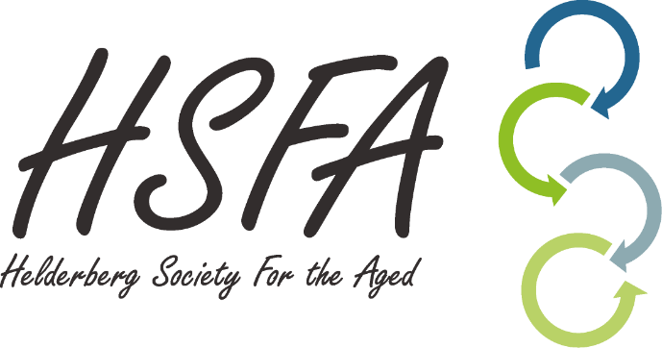

**RESIDENTIAL LEASE AGREEMENT: RESIDENT AND OR RESPONSIBLE PERSON GUIDE**

**Introduction**

This document is not a lease agreement. It is a tenant guide to some of the important terms in the HSFA Residential Lease Agreement in plain English. It is not a summary of the HSFA Lease Agreement and it does not replace the HSFA Lease Agreement in any way.

**Lease Agreement Resident / Responsible Person Guide**

1. **The Consumer Protection Act:** the residential lease agreement takes the requirements of the Consumer Protection Act (“the CPA”) into account so that you are fully protected as a consumer (clause 36).
2. **The Schedule:** the first part of the lease agreement (clause 1) is called the schedule where you will find specific information that you have agreed to with HSFA. For example, the lease start date or the rental amount.
3. **The Deposit:** you must pay the deposit on the same date that you sign the lease agreement. Although the deposit is kept by HSFA for the duration of the lease agreement, the deposit still belongs to you as the resident and or responsible person. HSFA may use the deposit to cover costs for damages to the premises when the lease comes to an end (clause 13). If there are no damages, the deposit will be returned to you.
4. **Interest:** You must pay the rent before the 1st (first) day of every month for the following month, unless HSFA collects the amount via debit order, which occurs on the 10th of the relevant month. If you do not pay the rent on time, you will be charged interest on the outstanding amount (clause 10). The rent may be increased every year by the percentage in 1.13 of the schedule.
5. **The Lease Term:** the length of the lease agreement (clause 5) is for a first period of less than 24 (twenty-four) months.
6. **Early Cancellation by the Resident and or Responsible Person:** the Resident and or Responsible Person may cancel the lease agreement at any time by giving 20 (twenty) business days’ notice in writing (clause 32). HSFA may charge a reasonable penalty for early cancellation which will not be less than the amount in 1.27 of the schedule.
7. **The End of the Lease Period:** when the lease period comes to an end, the lease agreement will continue on a month-to-month basis (section 14 of the Consumer Protection Act will no longer apply) unless you or HSFA decide to end the agreement before the lease period is over or unless it is extended for a further fixed-term period (clause 6).
8. **Notice of the End of the Lease Period:** HSFA must notify you in writing between 40 (forty) and 80 (eighty) business days’ before the end of the first lease period, of (i) the date the lease period is due to end; (ii) the fact that the agreement will continue on a month-to-month basis unless you end the lease at least 20 (twenty) business days’ before the end of the lease period, or you sign on for a further fixed-term lease period; and (iii) any important changes that will apply if the lease agreement changes to a month-to-month lease agreement (clause 7).
9. **Service Charges:** These charges include the credit check when you first sign the agreement, inspection fees and debt collections fees (clauses 1.11 and 1.12).
10. **Access to the Premises:** you need to allow HSFA access to the premises to perform a joint out-going inspection within 3 (three) days before the end of the lease (clause 14). You must also give HSFA access to the premises to make repairs or alterations but the landlord must in turn give you reasonable notice. If emergency work needs to be done, you must give the HSFA access to the premises immediately (clause 16).
11. **Maintenance:** you must repair any damage which you are responsible for, if you do not, HSFA may have the repairs done by a third party and claim the costs from you. If there is repair work that needs to be done which you are not responsible for, you must notify the landlord in writing as soon as possible (clause 15).
12. **The Resident’s obligations:** you must obey all laws and rules and return the premises in the same condition as you received it. This excludes the normal wear and tear that takes place in a property over time. You must not rent out part of the premises without the permission of HSFA or make alterations to the premises in any way (clause 17).
13. **Cancellation by the Landlord:** HSFA may cancel the lease agreement (i) by giving you 2 (two) months’ written notice if HSFA wants to change the use of the Premises or if HSFA wants sell the premises; and (ii) by giving you 20 (twenty) business days’ notice if you do not fulfil your obligations in terms of the lease agreement on 3 (three) separate occasions, for 3 (three) months in a row. This will apply even if you rectify the obligation you have not fulfilled at a later date; and (iii) immediately if you do anything that is criminal or illegal in the premises (clause 33).
14. **Cancellation by the Resident and or Responsible Person:** you may cancel the lease agreement without a penalty charge if HSFA does not fulfil an important obligation in terms of the lease agreement and continues to do so for 20 (twenty) business days after having received a written notice from you (clause 32). You may also apply to court to enforce your rights if HSFA does not fulfil an important obligation in terms of the lease agreement.
15. **Breach by the Resident and or Responsible Person:** if you do not pay the rent or any other amount due in terms of the lease agreement, or you do not meet your obligations in any other way, where (i) the CPA applies: HSFA may cancel the lease agreement by giving you 20 (twenty) business days’ notice; and where (ii) the CPA does not apply: HSFA may cancel by giving you 7 (seven) calendar days’ notice if you continue to not meet your obligations. In both cases, you must vacate the premises immediately (clause 34).
16. **Notices:** all notices given in terms of the lease agreement must be in writing and delivered to the addresses of the parties in 1.18 -1.20 of the schedule.
17. **Resident and or Responsible Person Information:** by signing this lease agreement, you give permission that HSFA may obtain any information to check your credit worthiness and payment patterns; and (ii) that your personal information will be processed for certain purposes (clause 42).
18. **Signature:** the lease agreement must be in writing and signed by the parties (clause 47). Signed includes a handwritten signature and advanced electronic signature (in terms of the Electronic Communications and Transactions Act). No changes to or cancellations of the lease agreement are valid unless they are in writing and signed. This means that the lease agreement cannot be changed or cancelled by, SMS or WhatsApp (an Email is acceptable for cancellation purposes).